## 

## Introduction

In this project you will learn to **create a web page from scratch** based on **one of the templates** to finally get a layout as similar as possible to the template**.**

## What are the main objectives in this project?

* Improve your knowledge of **Web Browser Tools**
* Improve your knowledge of **HTML**
* Improve your knowledge of **CSS**
* Improve your knowledge of **Frontend Development**

## 1. General analysis

The first step is to **analyze** the layout and design of the websites we provide to understand how to develop your exercise.

Then, you will have to **create a website that has the same layout and design**, from scratch, so that your website’s design and layout is **as similar as possible** to the original one.

You will have to find images to include in your website using the links provided in the resources, or you can use any resource you know that has images similar to the original designs.

**Your final version should be as similar as possible to the original one.**

### 1.2. Initial Designs

In this second part of “**Website from scratch**” you will have to make **new implementations** of **HTML** and **CSS ~~starting from the code of another team~~**. You must start from the **same design** to the one you have previously made.

**Design 1**

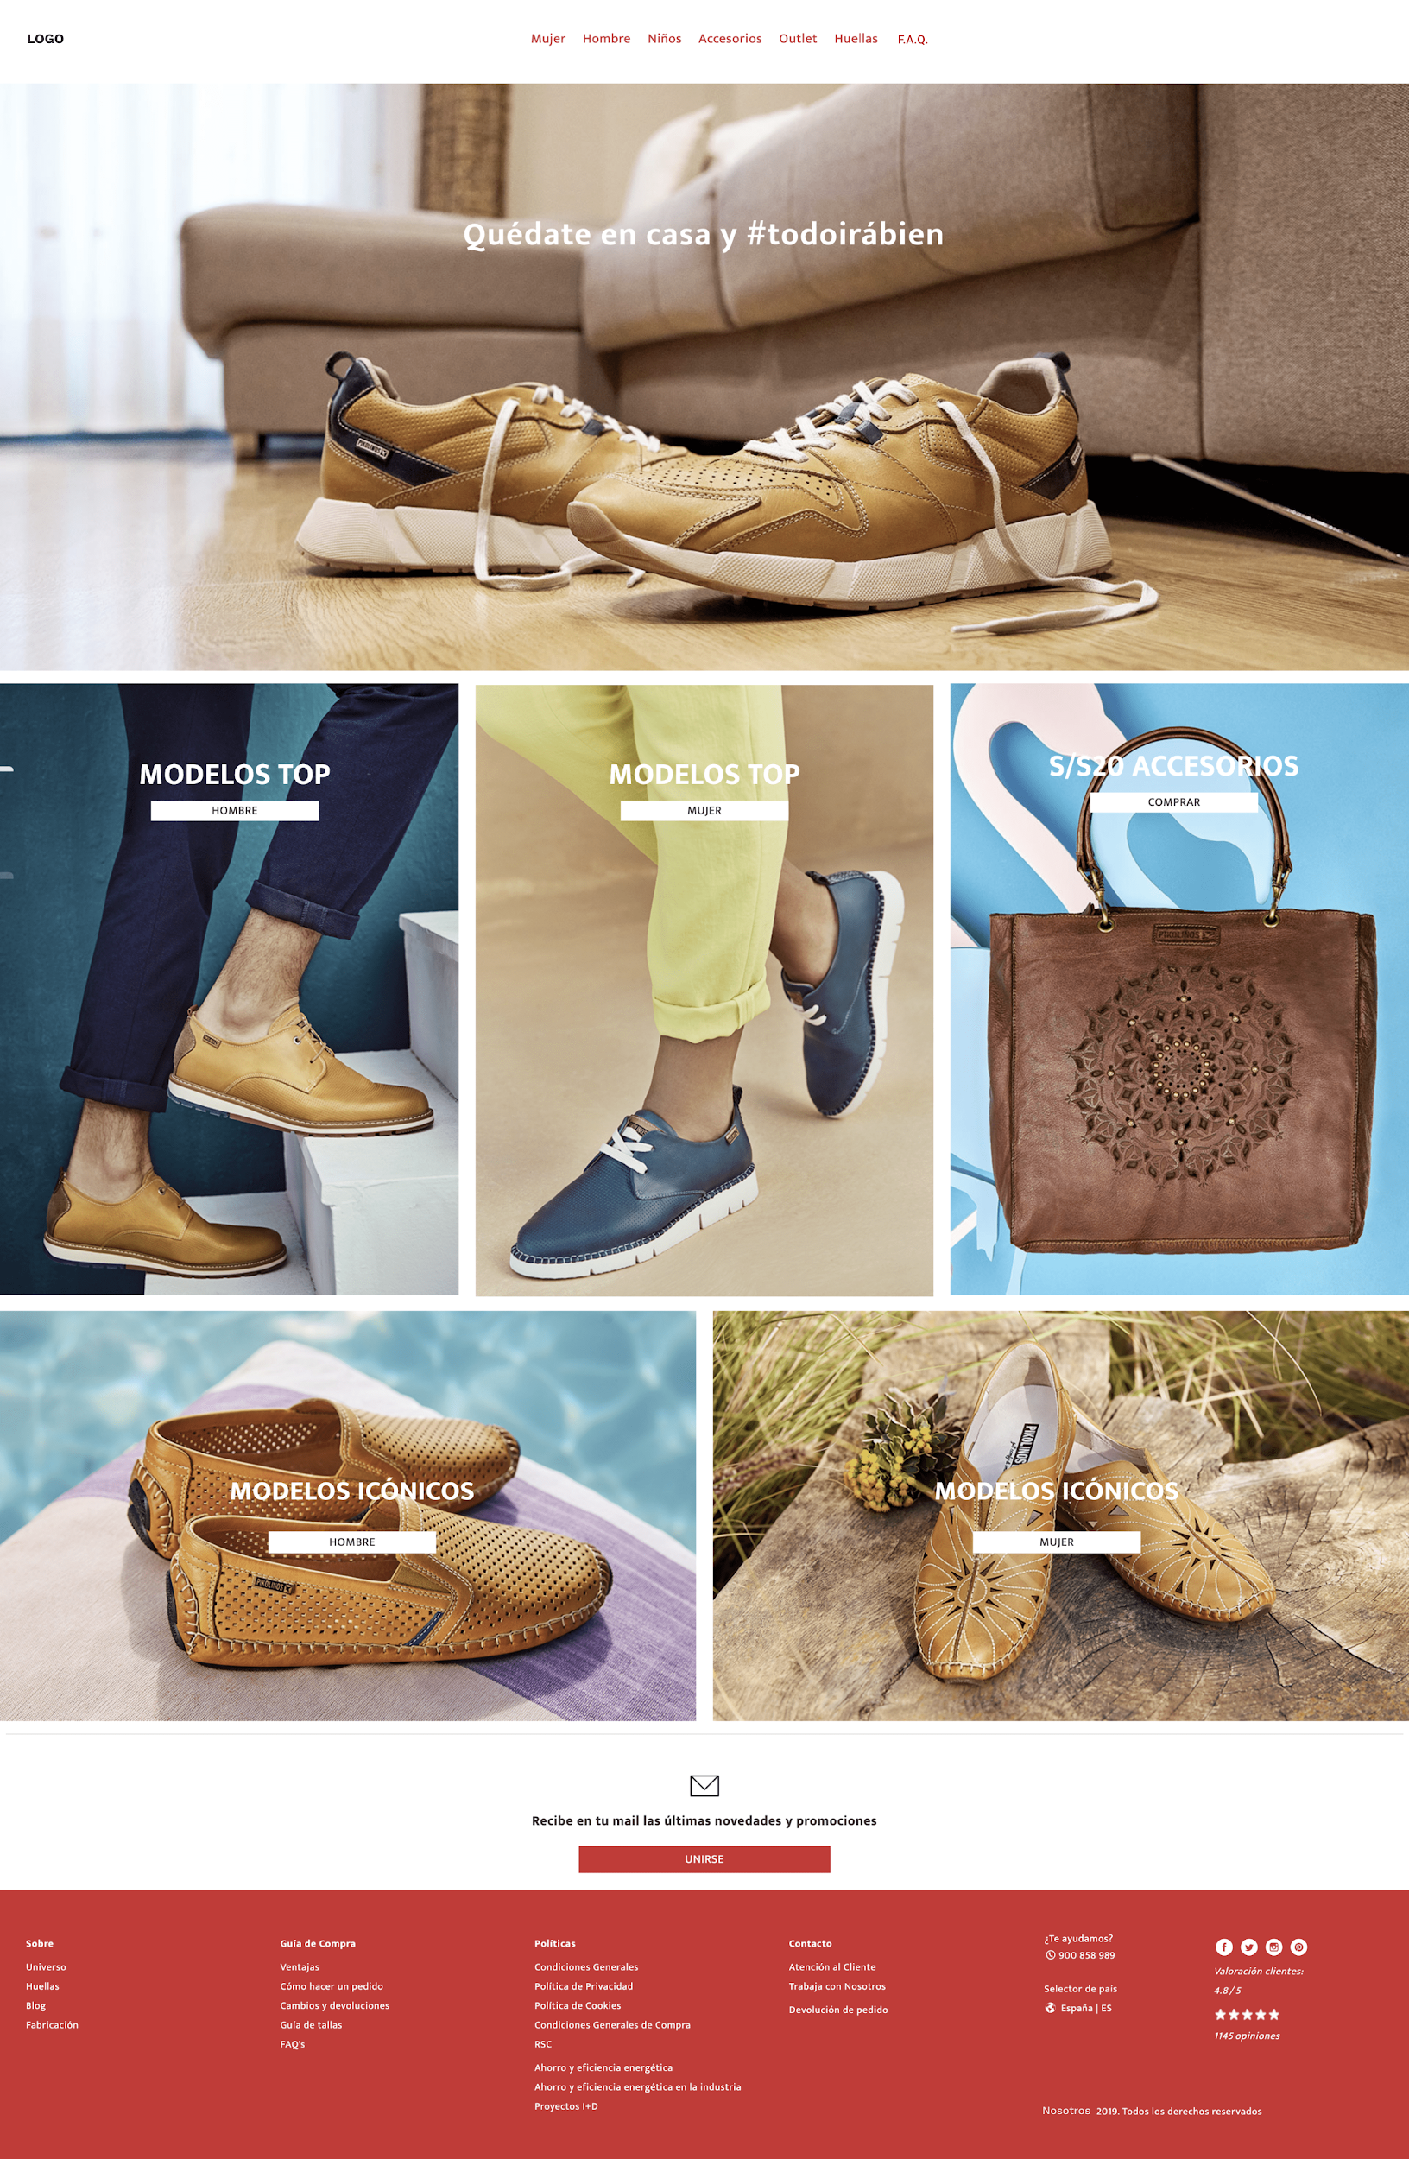

**Design 2**

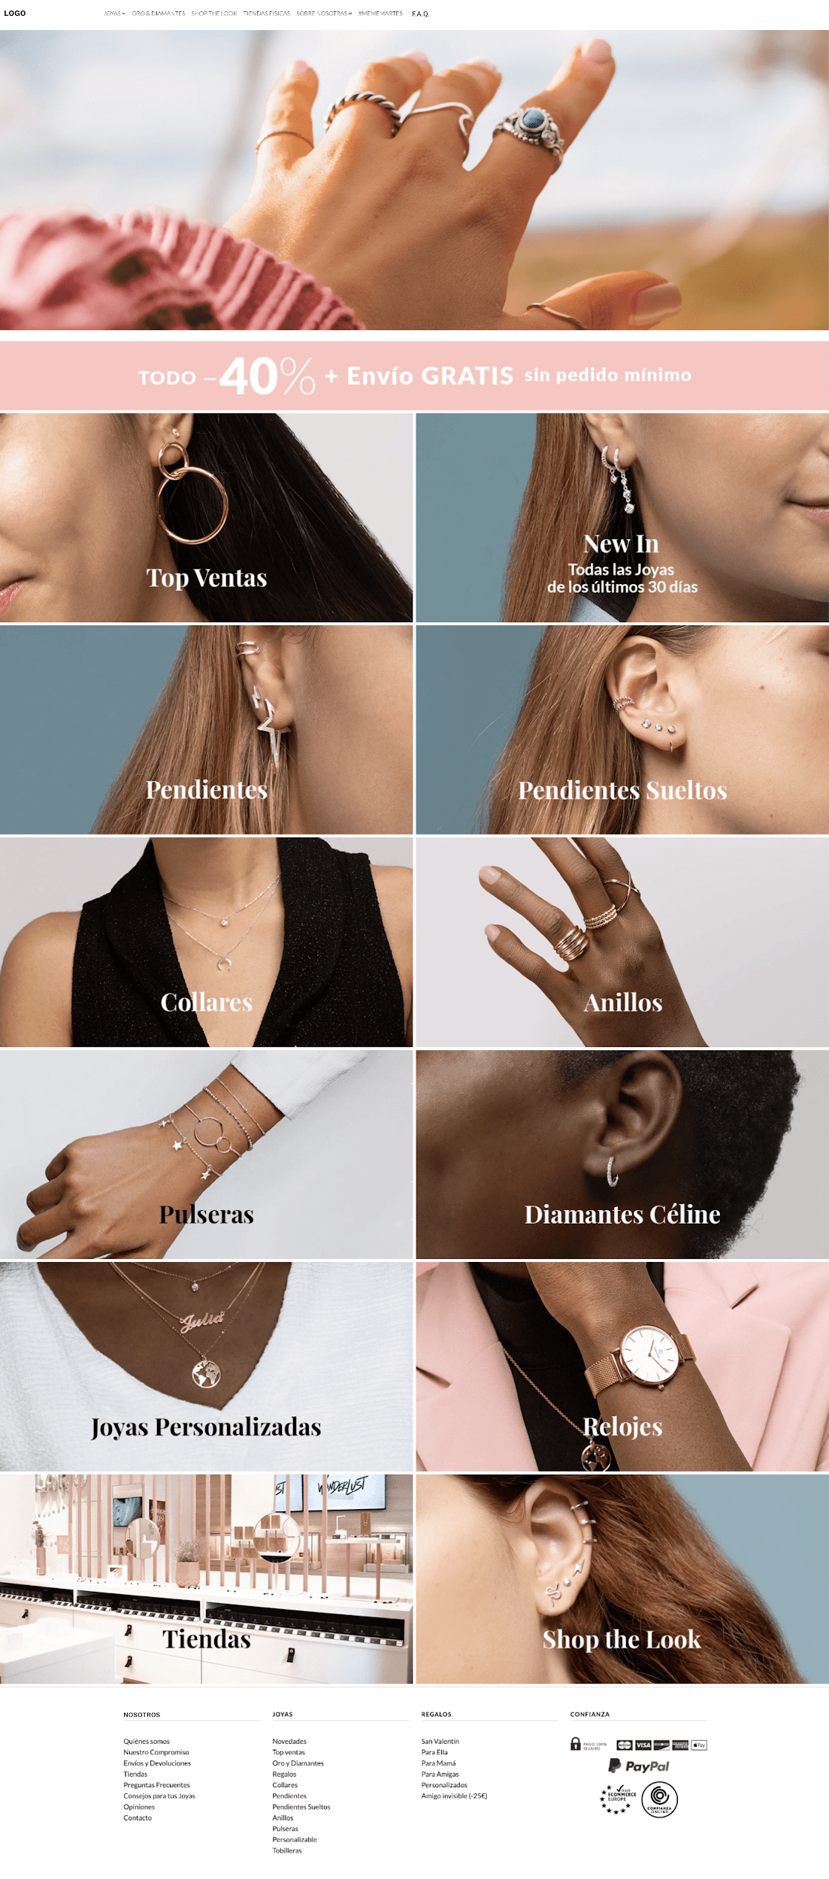

### 1.3. New implementations

Below are the **new pages** that must be implemented **in the design** that corresponds to your team:

1. Category Page
2. Product Page
3. Frequently Asked Questions Page

**Design 1: Category Page**

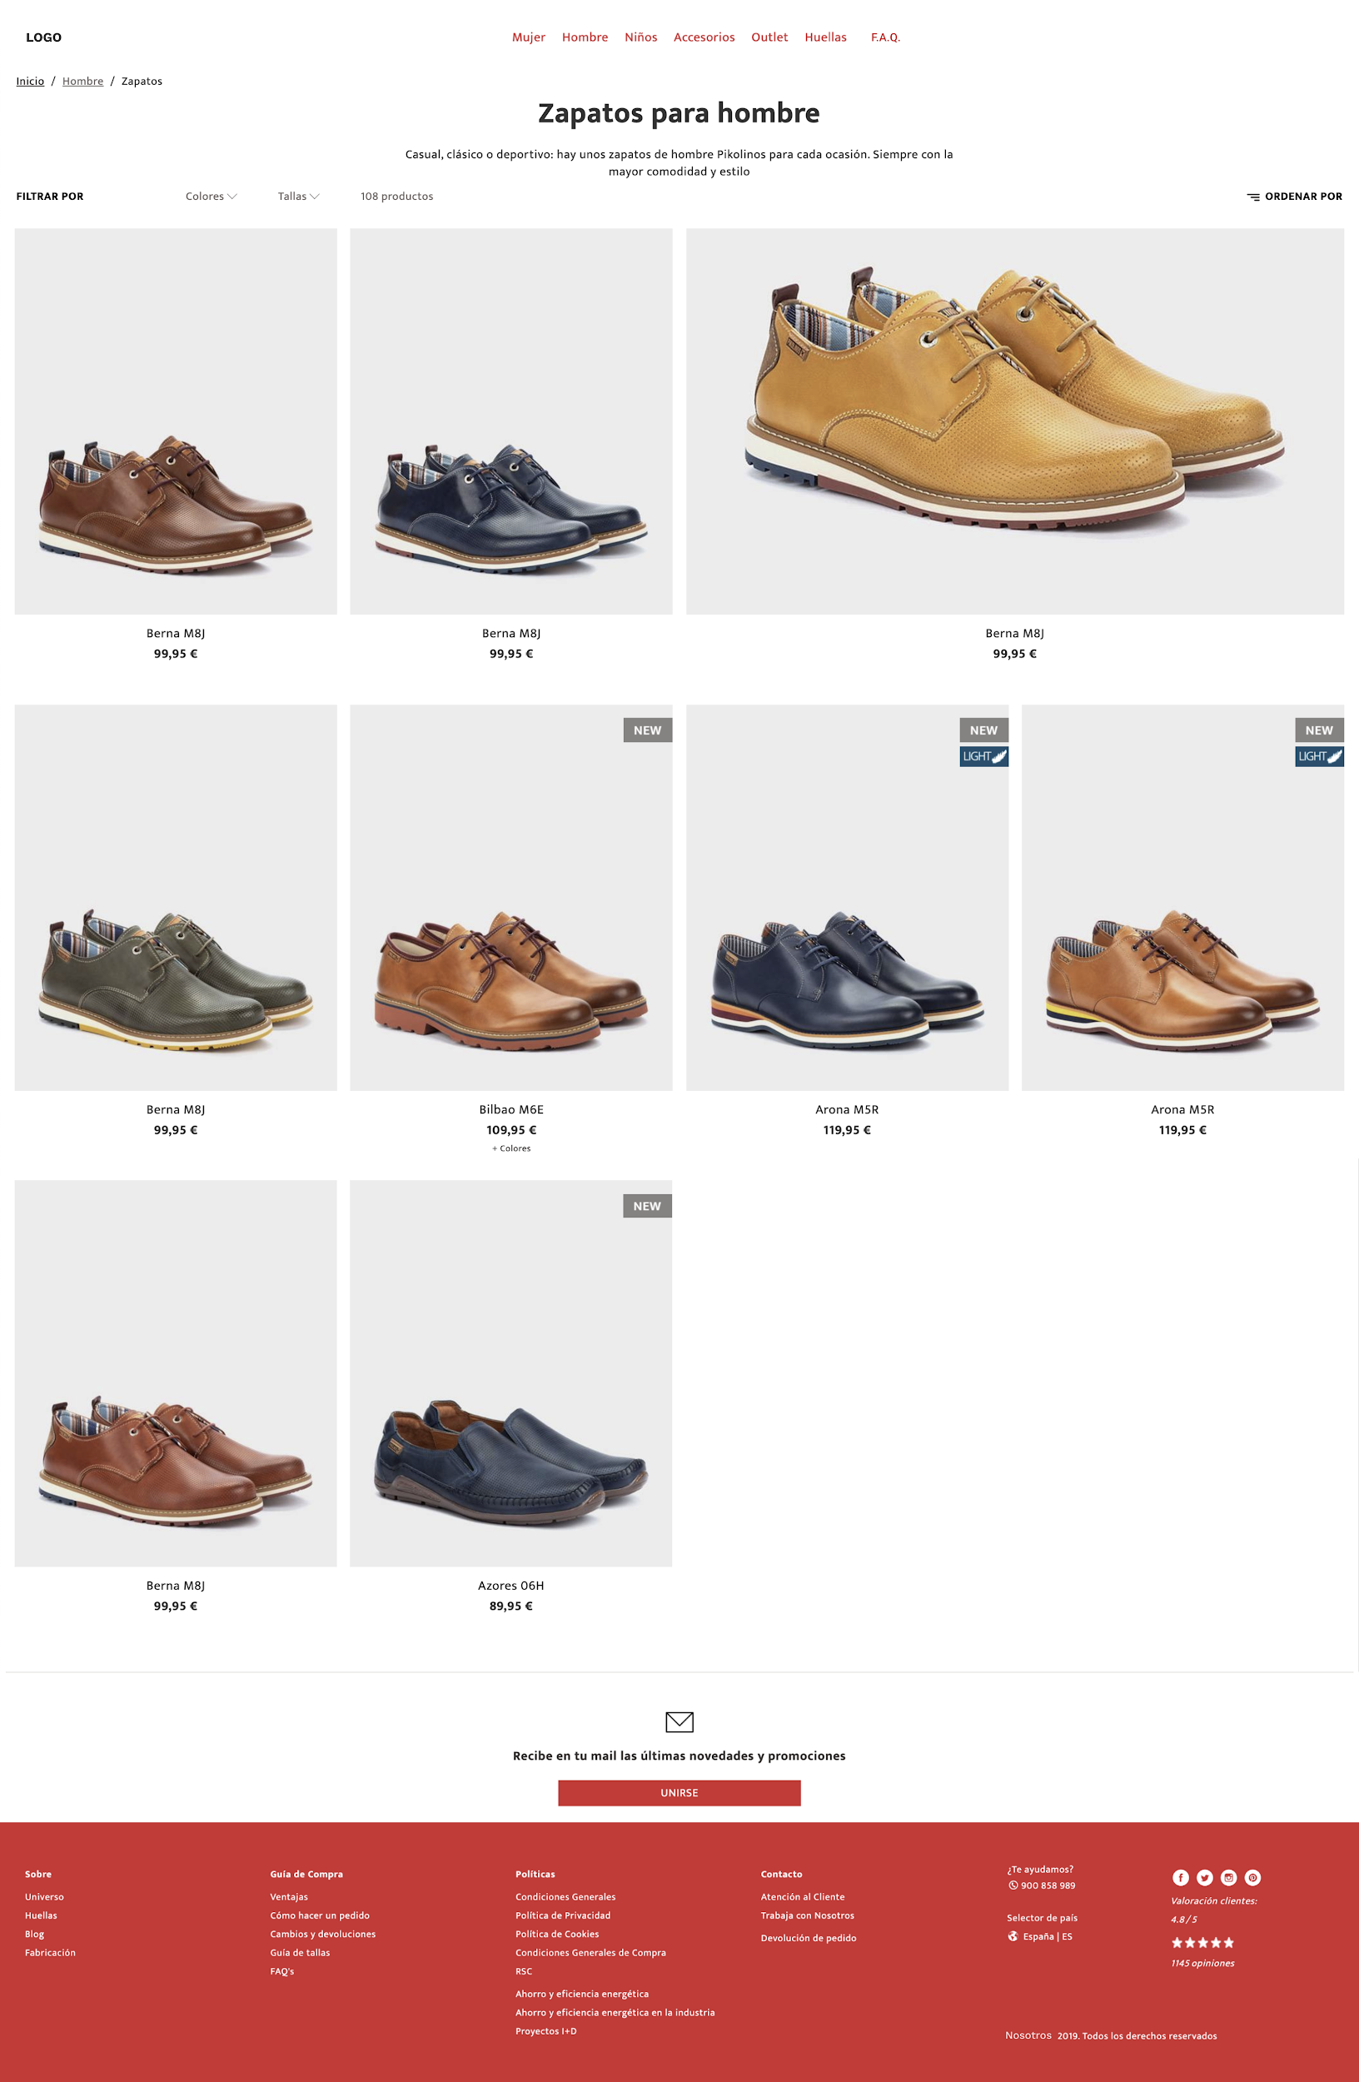

**Design 1: Product Page**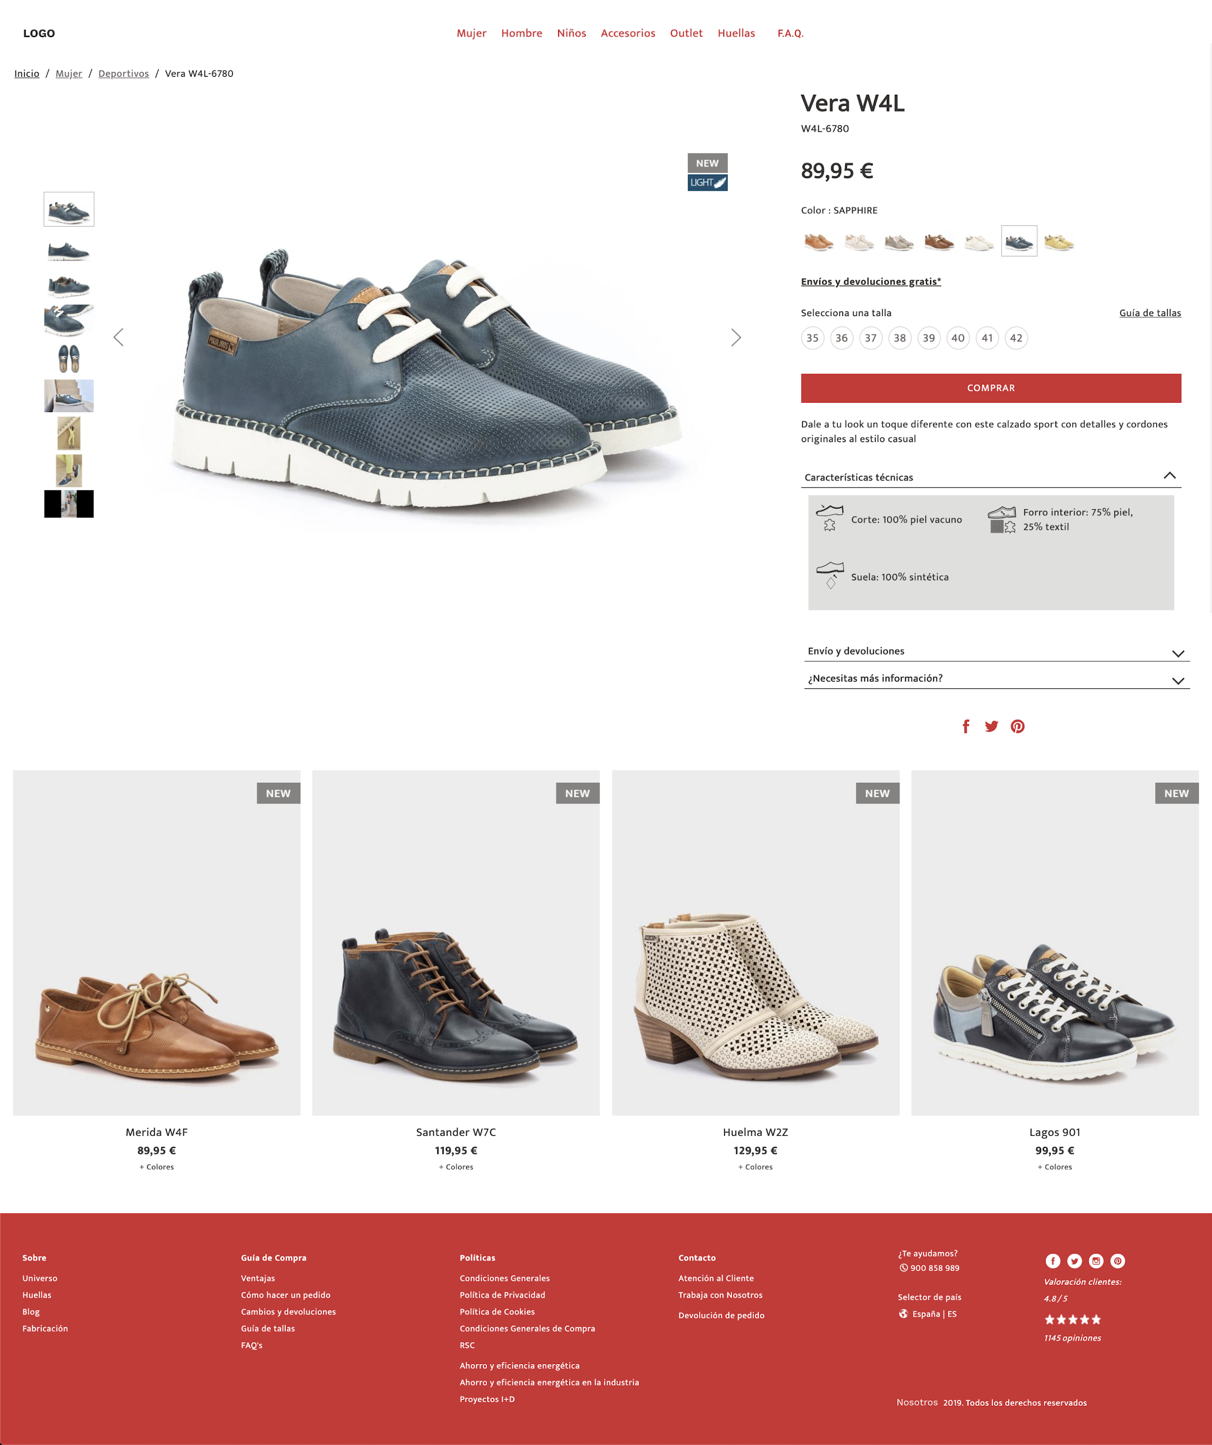

## 

**Design 1: Frequently Asked Questions Page**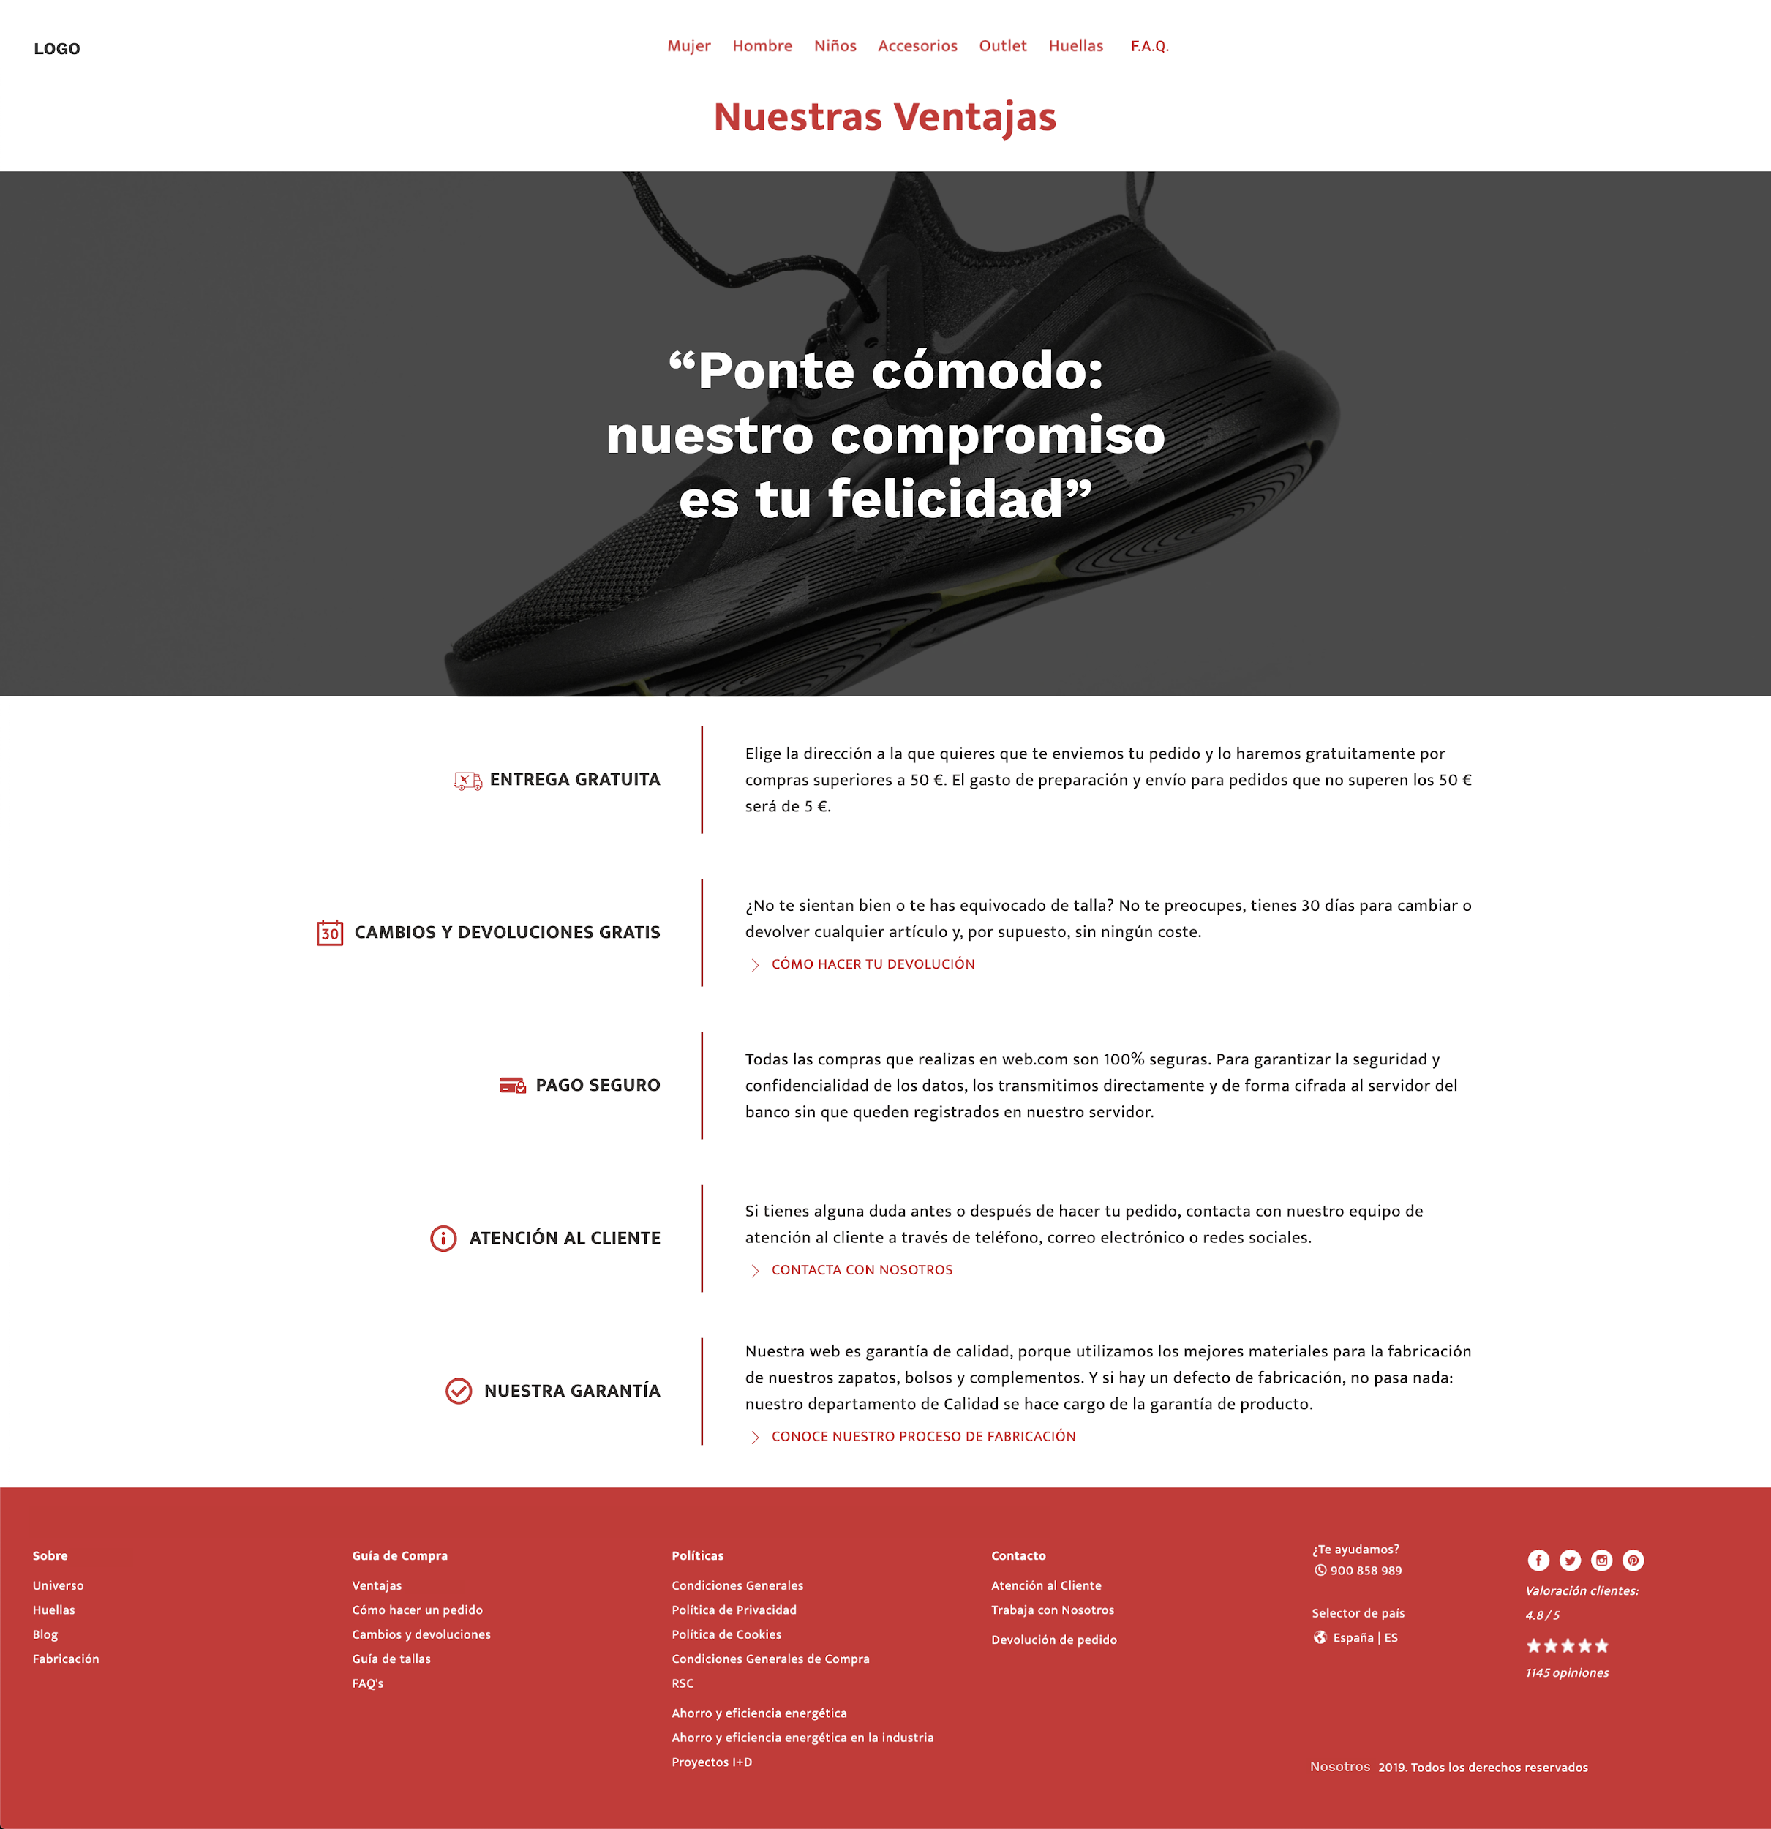

**Design 2: Category Page**

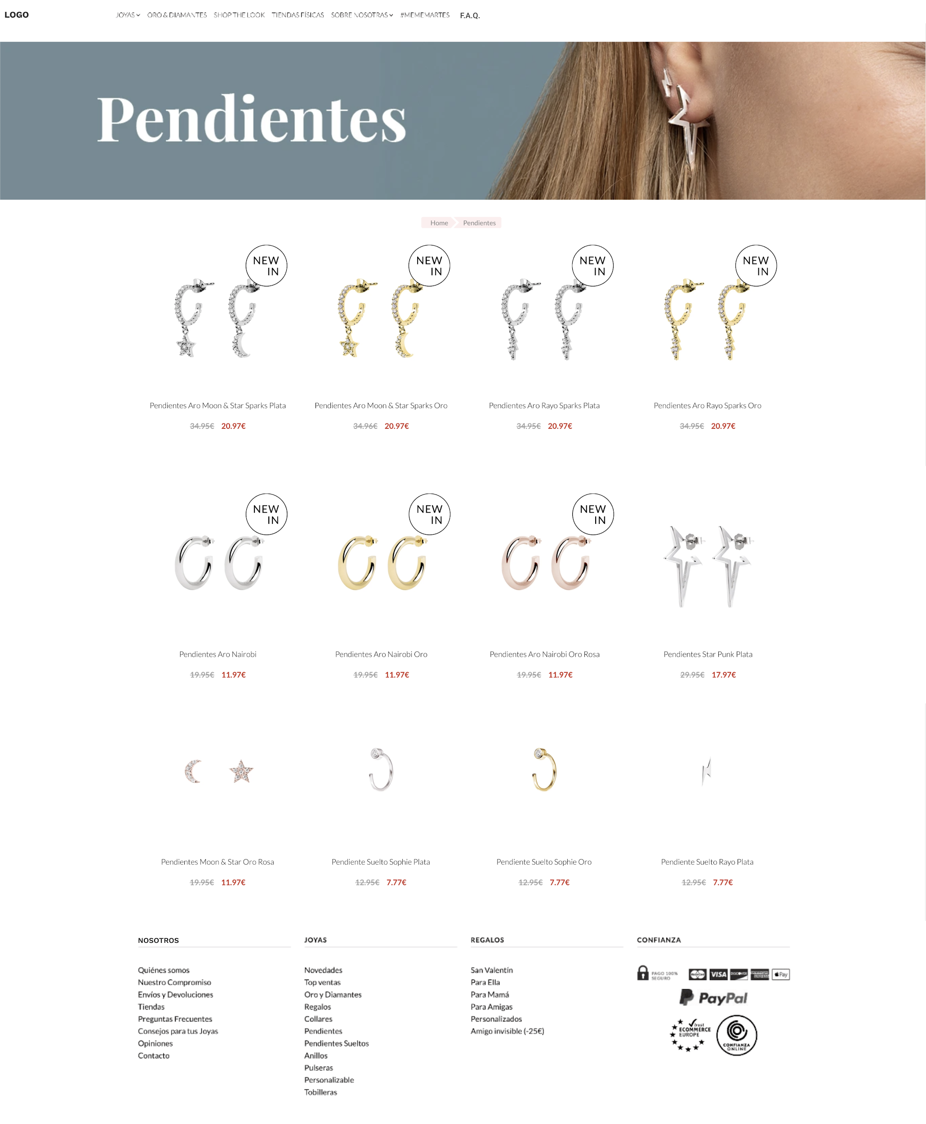

**Design 2: Product Page**

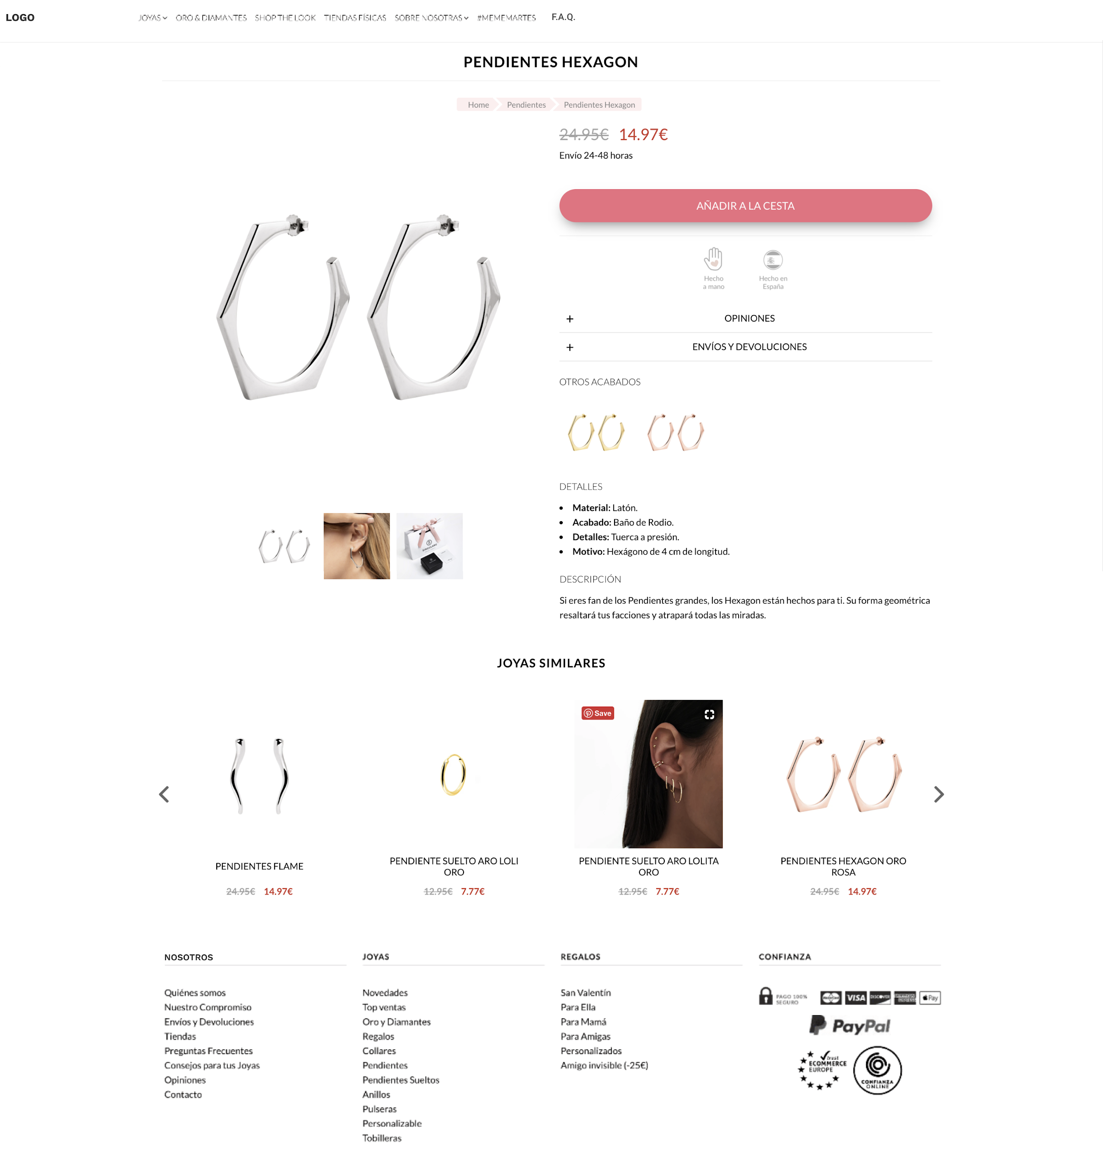

## 

**Design 2: Frequently Asked Questions Page**

## 

#### 1.3.1. Category Page

The category links from the home page of the first phase of the project will link to the category page.

You will have to create **a category page** that includes cards with a link to the product page.  
  
Create Product Cards

**Each product card will have to include at least:**

* an image of the product
* title of the product
* final price of the product
* a link to the product’s page

You must create a minimum of:

* **8 product cards** that have links to the product page
* **3 different working product pages** for each design

#### 1.3.2. Product Page

You will have to create at least 3 different working product pages for each design.

Each product page **will have to include at least**:

* The page’s main navigation header
* Section with the main info of the product with:
  + Product title
  + Product image
  + Product price
  + Additional information of the product
  + Main button to buy the product
* **A single section** with links to similar products
* Page footer

#### 

#### 1.3.3. Frequently Asked Questions Page

You will have to develop the Frequently Asked Questions Page for each design to include the questions and the main header image.

## 2. Requirements

Each webpage will have a different HTML file and a shared single CSS file for the entire website.

**You have to create at least:**

* You will use the home page from the previous exercise
* **1 Category Page** with a **link to the Product Page**
* You must use a **single external CSS file** for the entire website
* You **cannot** use third party libraries for the development of this pill
* You must take screenshots of the main browsers to ensure that the content is displayed correctly
* Both the code and the comments must be written in English
* You can use custom fonts from Google Fonts
* **You cannot use tables to create the layout**
* **The layout doesn’t have to be responsive**
* The characteristics of the page must be:
  + **Dimensions:**
    - Web page: **960px max-width**
    - Category Images: **468px** width with a spacing of **12px** between the images.
  + **Fonts:**
    - Design 1: Work Sans
      * <https://fonts.google.com/specimen/Work+Sans?stylecount=11&preview.text=&preview.text_type=custom&query=work+san>
    - Design 2: Playfair Display
      * <https://fonts.google.com/specimen/Playfair+Display?stylecount=11&preview.text=&preview.text_type=custom&query=playfair+display>

## 3. Deliverables

To evaluate the project you will need the following deliverables:

* Compressed folder (**.zip**) with the code and images used
* A **presentation** in **Google Slides** explaining:
  + Explain how you approached the development of the website
  + Explain what lessons you’ve learned during this pill
  + What **difficulties** you had

## 4. Resources

#### Google Drive folder with the initial designs

* + <https://drive.google.com/open?id=1XMiGqjHe2TTXaO9ZiGgnKjq0CIlCpLhl>

#### License free images:

* + <https://unsplash.com/>
  + <https://www.pexels.com/>

#### Open Source Icon Set

* + <https://iconscout.com/unicons/explore/line>

#### Google Fonts

* + <https://fonts.google.com/>